**1 Question Statement:**

Identify the rating distribution in the Shop_Nest data set, showcasing ratings categorized as Excellent, Very Good, Good, Bad & Very Bad, along with corresponding orders.

**Visualization:**

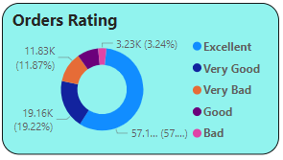

**Explanation:**

**Positive Feedback -** Majority of the feedback is positive, with **57.1%** rated as "Excellent" and **19.22%** as "Very Good", making up over **76%** of all responses.

**Moderate Feedback-** "Good" ratings account for **8.3%**, indicating a moderate level of satisfaction.

**Negative Feedback-** Only a small portion of the feedback is negative, with "Bad" ratings at **3.23%** and "Very Bad" at **11.87%**, totalling just under **15%**.

**2 Question Statement:**What are the Top 10 & bottom 18 most popular product categories in the ShopNest dataset? Please list them based on number of orders.

**Visualization:**

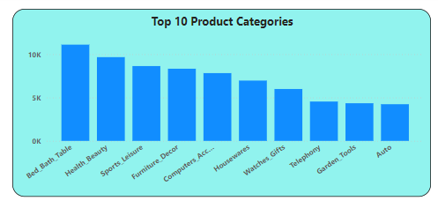

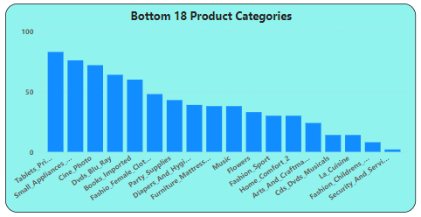

**Explanation:**

This analysis highlights the top 10 and bottom 18 performing product categories based on number of orders with respect to each product category.

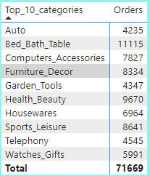 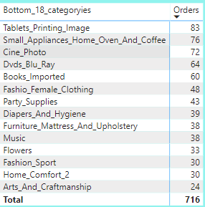

**3 Question Statement:**List total number of active sellers by yearly and monthly.

**Visualization:**

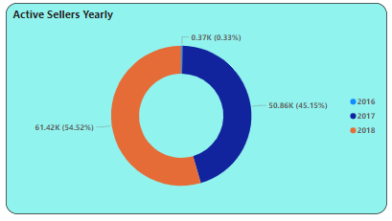

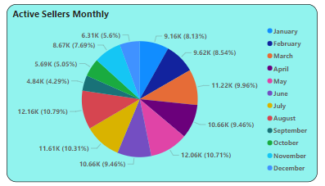

**Explanation:**

**Active Sellers Yearly -** There is raise in active sellers in consecutive years. Where active sellers in the year 2016 is just 0.33%, a big jump to 45% in 2017 & even further spikes to 54% in 2018.

**Active Sellers Monthly –** From January to August, we can see positive trend, major dip is experienced in the month of September and the same fall is continued for next 3 months with slight fluctuations.  
This gives us an observation that we are experiencing very less number of active sellers in quarter 4.

**4 Question Statement:**

Which payment methods are most commonly used by ShopNest customers?

**Visualization:**

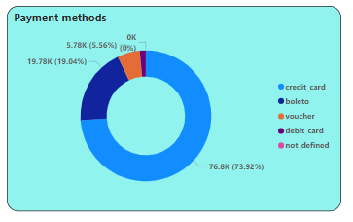

**Explanation:**

Top most payment method used is “Credit Card” with 74%, followed by “Boleto” with 20% and rest of the 6% is shared by “Voucher” and “Debit card”.

**5 Question Statement:**

Identify the product category wise profit margin using the formula   
(Payment value – price + Fright value) / Payment Value * 100 (Rounded to two decimal points).

**Visualization:**

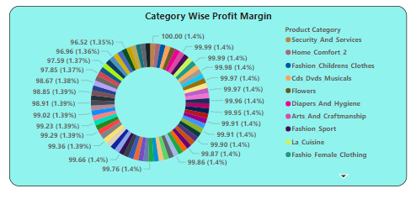

**Explanation:**

We have 5 product categories with 100% profit margin – “Security_And_Services”, “Home_Comfort_2”, “Fashion_Childrens_Clothes”, “Cds_Dvds_Musicals” and “Flowers”.

And multiple categories we have with 99% profit margin, which gives us an observation that there is a high profit margin in many product categories.

**6 Question Statement:**

Determine the monthly payments made by customers using credit cards?

**Visualization:**

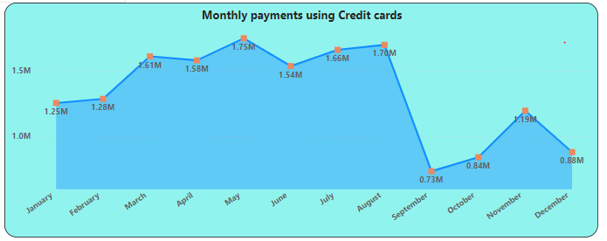

**Explanation:**

From January to August, we can see positive trend with slight fluctuations, major dip is experienced in the month of September and continued for next 3 months with slight fluctuations.  
This gives us an observation that we are experiencing very less number of customers using credit cards at end of the year, from September to December.

**7 Question Statement:**

Identify sellers categorized by city, excluding cities starting with the letters S and B.

**Visualization:**

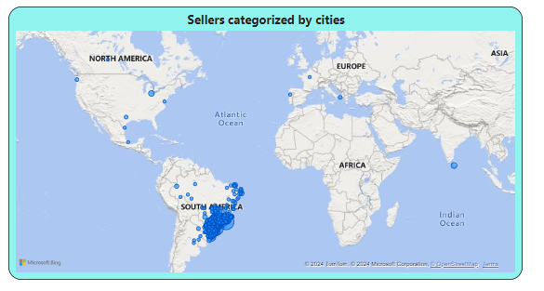

**Explanation:**

Total sellers across the globe, we have are 3095. After categorizing the by cities and excluding cities starting with the letters S and B, we get 1790 sellers.

We have Majority of the sellers from South America and the top 3 cities are “Curitiba”, “rio de janeiro” and “ribeirao preto”.

**8 Question Statement:**

Create a dynamic visual that compares the number of delayed orders to the number of orders received earlier for each month. Utilize the drill through the cross-report feature to provide a detailed analysis of late and on-time deliveries.

**Visualization:**

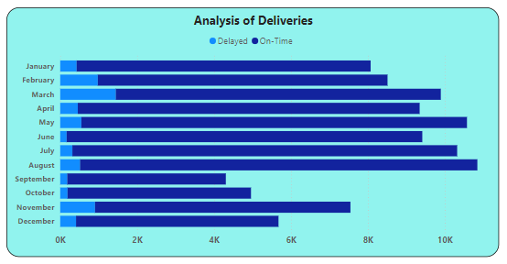

* On-Time Delivery analysis using drill through the cross-report feature

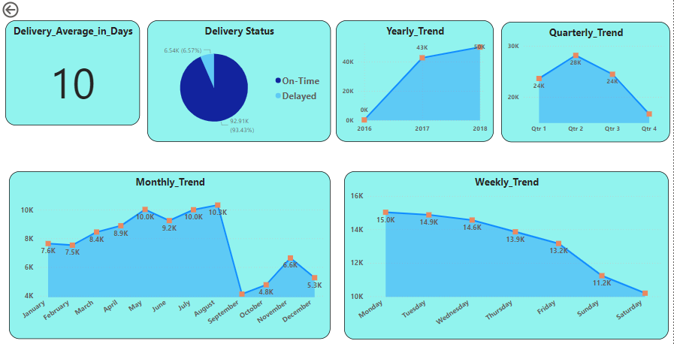

* Delayed Delivery analysis using drill through the cross-report feature

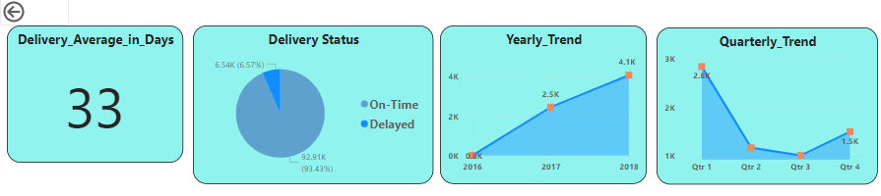

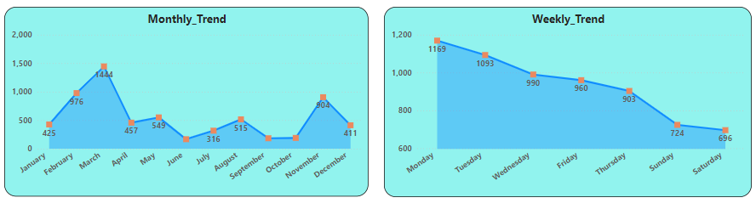

**Explanation:**

**On-Time Delivery Analysis -** Orders delivered on an average in 10 days, with 93.5% on-time & with 6.5% delayed rate. Yearly the trend is spiking, quarterly we have quarter 2 in top place, followed by quarter 1 & quarter 3. Monthly first 8 months we have positive trend and in the last 4 months we experience dip with fluctuations. And coming to weekly trend analysis we have more orders delivered on-time on weekdays compared to weekends.

**Delayed Delivery Analysis** - Orders delivered delayed with an average of 33 days, quarterly we have quarter 1 and 4, where the most of the orders got delayed in delivery compared to quarter 2 and 3. At monthly trend during first 3 & last 2 months of the year are more delayed and rest of the months has less delay with slight fluctuation’s. And coming to weekly trend analysis we have more orders delayed in delivery on weekdays compared to weekends.